Build a Better World • June 2017
Sunday | Monday | Tuesday | Wednesday | Thursday | Friday | Saturday
Apprentice programs-for ages 0-5 years, includes interactive story times, hands-on crafts & activities to teach parents and caregivers techniques and skills to benefit their child.  Journeyman programs-for ages 6-12 years, includes STEAM initiatives, reading, encourages creative exploration, active skill-building, & critical thinking.  Harvester’s Snacks served weekly on Tuesdays & Thursdays after the 2 pm programs.  PROGRAMS WILL BE HELD IN THE LIBRARY’S LOWER LEVEL UNLESS INDICATED |  |  |  | 1 KICKOFF EVENT!  10 am-ROCKIN’  Rob Show  2 pm-ROCKIN’  Rob Show  3 pm-Harvester’s Snacks | 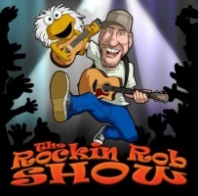  2 | 3
4  2 pm- I Choose Recovery (for adults & families) | 5  10 am-Apprentice  Story Time  2 pm-Journeyman  Story Time  2 pm-Outreach to Austin Home & Jefferson Park | 6  REPEAT TUESDAY!  10 am-Apprentice  Story Time  2 pm-Journeyman  Story Time  3 pm-Harvester’s Snacks | 7  Library open until 8 pm! | 8  10 am-Apprentice  Story Time  2 pm-Journeyman  Story Time  3 pm-Harvester’s Snacks | 9 | 10
11  2 pm- I Choose Recovery (for adults & families) | 12  10 am-Apprentice  Story Time  2 pm-Journeyman  Story Time  2 pm-Outreach to Austin Home & Jefferson Park | 13  10 am-HOOPLA  Storyteller WILL STUCK  2 pm- BOOM Science! Storyteller WILL STUCK  3 pm-Harvester’s Snacks  6 pm-Park Board Mtg | 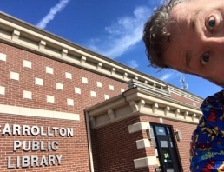  14 | 15 10 am-Apprentice  Story Time  2 pm-Journeyman  ECLIPSE VIEWERS  3 pm-Harvester’s Snacks  6 pm-Total Eclipse of the Heartland Informational meeting at Rupe Center  7 pm-MU Extension mtg | 16 | 17  9 am –ARES/HAM Radio meeting
18  Happy Father’s Day! (Library closed)  2 pm- I Choose Recovery (for adults & families will meet) | 19  10 am-Apprentice  Story Time  2 pm-Journeyman  Story Time  2 pm-Outreach to Austin Home & Jefferson Park | 20  REPEAT TUESDAY!  10 am-Apprentice  Story Time  2 pm-Journeyman  Story Time  3 pm-Harvester’s Snacks | 21  Library open until 8 pm! | 22  10 am-Mad Scientists @ CES Gymnasium  2 pm-Mad Scientists@ CPL lower level  3 pm-Harvester’s Snacks | 23 | 24
25  2 pm- I Choose Recovery (for adults & families) | 26  10 am-Apprentice  Story Time  2 pm-Journeyman  Story Time  2 pm-Outreach to Austin Home & Jefferson Park | 27 REPEAT TUESDAY!  10 am-Apprentice  Story Time  2 pm-Journeyman  Story Time  3 pm-Harvester’s Snacks  4:30 pm-Library Board Mtg | 28  Library open until 8 pm! | 29  10 am-Apprentice  Story Time  2 pm-Journeyman  Story Time  3 pm-Harvester’s Snacks | 30 | 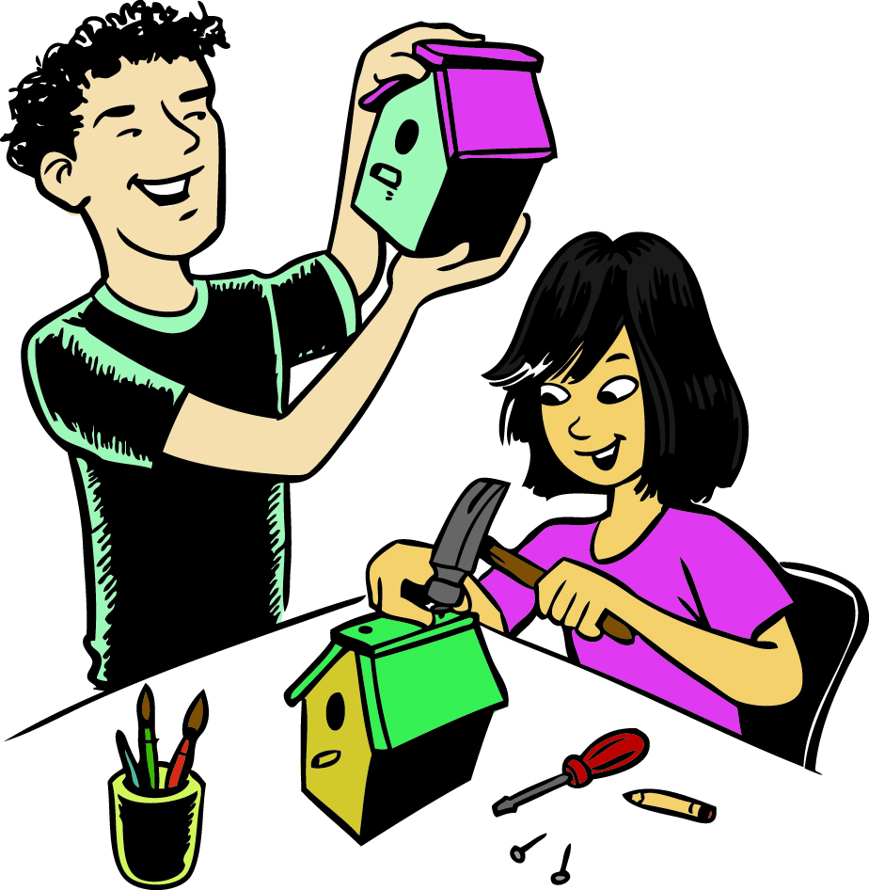
One North Folger Street, Carrollton, MO 64633 Phone: 660-542-0183 www.carrolltonlibrary.com
Find us on FB! https://www.facebook.com/pg/Carrollton-Public-Library-127287750675022

